Gamma Spectroscopy

Kitty Harris. Lab conducted with Josh Elsarboukh.

**Abstract.**

Gamma Spectroscopy is a technique for identifying materials based on their emission of high-energy photons. Through either beta or alpha decay, nucleons can reach excited states that are unique to the isotope they belong to. When these nucleons return to the ground state, they emit a gamma particle of energy equal to the energy lost this way. We used a multichannel analyzer in pulse height mode to find peaks in gamma emissions of various known substances, the centers of which we then fitted linearly against bin number to create a calibration curve in which bin number corresponds to gamma energy. An unknown substance was then measured and compared with this calibration curve; it was found to be a combination of 137Cs and 65Zn.

**I. Introduction to Gamma Decay**

Gamma decay is the emission of a high-energy photon – typically between 0.01[MeV] and 10[MeV] – due to the return to ground state of an excited nucleon (proton or neutron); this process is similar to the emission of a photon due to return to ground state of an excited electron. It is, however, exceedingly rare for a particle to reach an atom’s nucleus in order to put a nucleon into an excited state; therefore, gamma radiation almost always follows another form of radiation. These two other types of radiation are known as alpha and beta decay.

Alpha decay – the ejection from the nucleus of the highly stable alpha particle, which is identical to a 4He nucleus – causes the source’s energy and element to change. This can result in nucleons now being in an excited state where they were not before because the energies of the ground states have changed. In alpha decay, the sum of energies of the alpha particle and the source atom after losing the alpha particle are less than the energy of the original source atom, making it favorable for the alpha particle to tunnel out of the nucleus, escaping the source. Momentum and energy are conserved by emission of a photon with momentum opposite the nucleus and energy equal to that which would be lost.

Beta decay is the conversion of a neutron to a proton

$$n→p^{+}+e^{-}+\overline{ν_{e}}$$

or vice versa

$p^{+}→n+e^{+}+ν_{e}$.

This spontaneous decay occurs if changing from the current element to another atom with the same mass will result in a lower and therefore more favorable energy. We see that this decay conserves charge by emitting an electron or positron; it must therefore also emit an anti-electron neutrino or an electron neutrino, respectively, to conserve a quantum value known as lepton number. The electron and neutrino are ejected from the nucleus, but the nucleon stays, possibly leaving the new nucleon or a nearby nucleon in an excited state.

Now we have a nucleon which can return to its ground state. While much of gamma decay occurs directly, where a photon is simply emitted by the nucleon itself, it is also possible for this change in state to result in pair production. This can occur only if the difference in energy between states is at least the sum of the rest mass energies of an electron and a positron:

$ΔE≥2m_{e}c^{2}≅1[MeV]$.

The pair will quickly annihilate, resulting in photons of the same energy as the produced pair. Therefore, this indirect decay has almost the same overall effect as direct decay, with one big exception; by conservation of momentum, there must be multiple photons. This is because, for the electron-positron pair, there is a rest frame (that is, it is possible to define coordinates such that the total momentum between the two particles is zero), so whatever results must also have a rest frame. While there is no rest frame for a single photon (all photons have momentum), there is a rest frame for two photons; the overall momentum for two photons of the same frequency travelling in opposite directions is zero.

**II. Theory Behind Gamma Spectroscopy**

All isotopes have a unique combination of protons and neutrons. Protons repel each other by electromagnetic forces, but these forces have no bearing on neutrons, and this repulsion becomes smaller at greater distances. At the same time, nucleons attract one another via the nuclear strong force, which increases with distance but cuts off abruptly past a certain distance. For larger isotopes, this means that some pairs of nucleons aren’t interacting at all, and some pairs of protons are repelling one another because they are interacting only through electromagnetism.

The result of this is that nuclei in different isotopes have different excited states. Therefore, isotopes must have varying gamma energies associated with these different excited states. While calculating the exact gamma energies of an isotope would be incredibly complex, there are accepted measured values that we can use to identify an isotope. This is what is meant by gamma spectroscopy; each isotope has a gamma “fingerprint” which we can use to identify it, so long as we can measure the energies of the emitted photons in some way.

**III. Setup & Equipment**

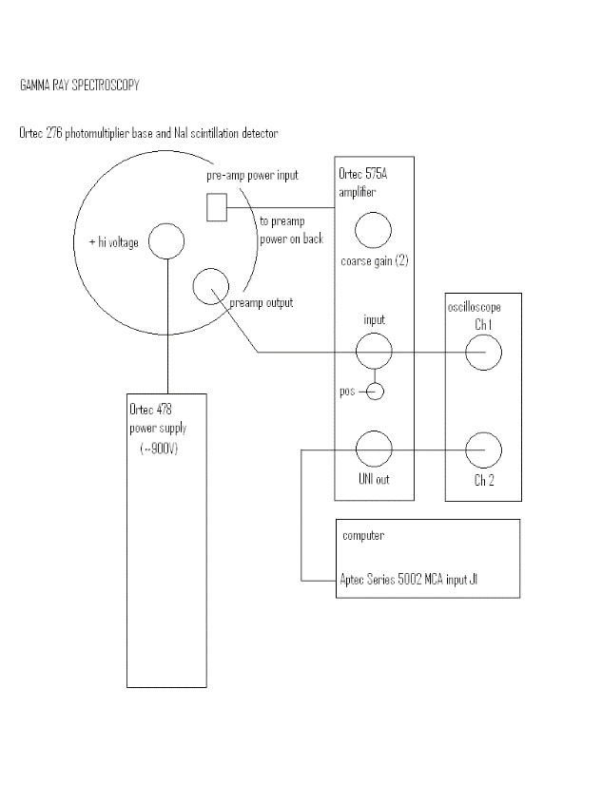

A chamber housed our samples while they were being measured. Gamma rays passed through a scintillator which split these rays into more, smaller-energy photons so that they would be at more easily detectable energy levels. A photomultiplier tube converted these photons into an electric input that was then amplified back to a proportionate energy and read by a digital oscilloscope. Finally, this data was sent to a multichannel analyzer which was connected to a computer for analysis. I will go into further detail on each of these components below.

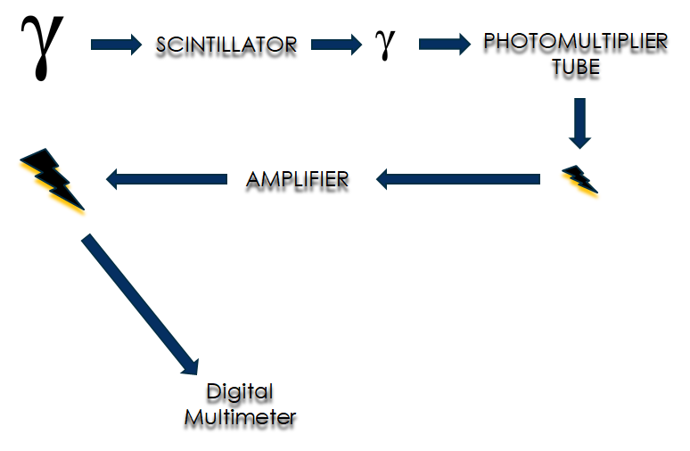

The scintillator is a block designed such that it is likely for gamma particles to undergo what is known as Compton scattering. Compton scattering occurs when a photon collides with a particle – in our case, an electron – but only transfers part of its energy. Electrons that are excited will return to ground state, emitting a photon with energy equal to the energy lost. Electrons which are ejected from their atoms will eventually collide with other electrons, causing a cascade in energy exchange. These electrons continue colliding until they lack the energy to do so; each time, they either knock more electrons free or excite an electron, so they eventually result in photon emission. It is also possible, with gamma particles of 1[MeV] or higher, that pair production occurs. In this case, the positron annihilates with the nearest electron, but the electron will collide as described before. Regardless of which of these processes occurs, the result is that we now have multiple photons with a total energy equal to that of the original, but with individual energies much less than that of the gamma particle.

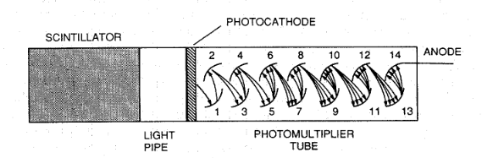

The photons strike a photocathode upon arriving at the photomultiplier tube. Through the photoelectric effect, these photons force electrons out of the photocathode, creating an electric current. Electrons strike a series of dynodes within the tube; these are curved panels angled such that incoming electrons will cause more electrons to be ejected toward the next dynode. The final dynode acts also as the anode.

After it passes through the photomultiplier tube, we send the current through an amplifier to make the energy we are reading match the energy input to the system; that is, we “undo” the division we did in the scintillator. Now this current can be sent through the oscilloscope to be measured.

The final step before we can analyze our data is to send the current through a multichannel analyzer (MCA). This is a device that records data about a signal consisting of pulses. For our experiment, these pulses are of voltage readings. Data was taken over the course of five minutes, and each incoming pulse during this time period was placed in a bin (also known as a “channel”, functioning as a sort of index for arbitrarily definable values). So, the output provided data for bin number and the number of pulses that were sorted into that bin (referred to as “counts”). We used Pulse Height Analyzer (PHA) mode, which sorts pulses according to their amplitude. This way, each channel corresponded to an incoming voltage and therefore to a given energy $E=qV$. While some MCAs are digital, ours used an analog to digital converter, converting continuous data into discrete values so that they can be read by the computer. While some more recent models of MCAs have their own microprocessors, ours was connected to a computer for analysis.

**IV. Procedure**

We began by measuring the spectra of five known substances – 133Ba, 109Cd, 60Co, 54Mn, and 22Na. Each of these had their spectra measured for five minutes. The peaks in these data were found and used to create a calibration curve. We also took control data over ten minutes, but found no significant emission in this control data, so there were no peaks that we determined to be caused by background radiation. We then measured our unknown substance and used the locations of the peaks in its spectrum to determine its emitted energies by comparing them with the function of the calibration curve. Finally, these energies were compared with a table of known values to determine what elements were present.

**V. Analysis**

The first step in calculating our results, and therefore in propagating our error, was to find what bins corresponded to what energies by comparing known values. In order to do this, we imported each known source’s data to MATLAB and plotted it in the curve fitting app. Each emitted energy was represented as a peak in the data, so we limited the region over which MATLAB would analyze the data so as to isolate each gaussian. Using a gaussian fit, MATLAB gave the center of the peak and automatically provided an uncertainty based on *χ2*; I rounded each of these up to the nearest bin number, as that was our equipment’s resolution.

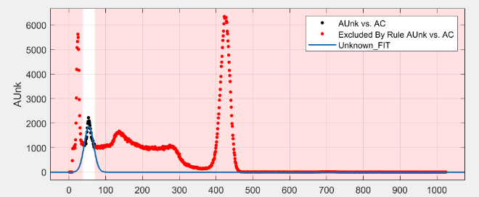

The next step was to create our calibration curve, giving a continuous relationship between bin number and energy. This was done in python. We created three corresponding arrays — one for energy, to be used as the x-data; one for bin number, to be used as the y-data; and one for the bin numbers’ uncertainties. We then used weighted linear regression to fit an equation associating energy with bin number while accounting for previously determined uncertainties. A covariance matrix allowed us to calculate uncertainties in the slope and intercept. Finally, we calculate our energies for the unknown substance by plugging a bin number into the acquired function, using

$E=\frac{C-b}{m}$,

Where *E* is the energy, *C* is the channel number, *b* is the intercept, and *m* is the slope. Error propagation followed the form of

$σ_{f}^{2}=Σ{\left(σ_{i}\frac{df}{di}\right)}^{2}+\sum_{i}{\sum_{j≠i}{\left(\frac{df}{di}\frac{df}{dj}s_{ij}\right) }}$,

Where the cross terms are dropped because $s_{i,j≠i}$ is always zero in our case. This meant that our final term for uncertainty was

$σ_{E}=\left(\sqrt{σ_{C}^{2}+σ_{b}^{2}+\frac{σ_{m}^{2}}{m^{2}}}\right)\frac{1}{m}$.

During this process, we elected to omit the data collected from 133Ba and 109Cd because the peaks were difficult to discern and there were more peaks than expected for either element. We believe this to be a result of the age of these samples being significant when compared with their half-lives. It is entirely possible that resultant elements exist within both samples, and that these resultants have their own gamma spectra that were interfering with our data. Emitting these sources gave us a curve fit with a much better goodness-of-fit than the curve fit including these sources.

**VI. Results & Conclusion**

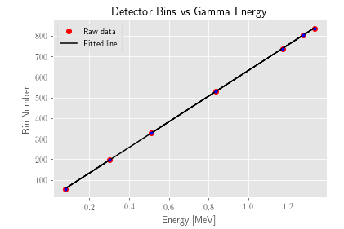

The curve fit we obtained was

$C=618.03E+13.22$.

This gave us unknown energies of 0.670±0.007[MeV], 0.024±0.007[MeV], 0.072±0.007[MeV], and 1.16±0.01[MeV]. These were compared with a table of known values. Knowing that our original source consisted of only one or two elements, we concluded that the energy 0.670±0.007[MeV] corresponded to the 0.662[MeV] emission of 137Cs and that the 1.16±0.01[MeV] corresponded to the 1.15[MeV] emission of 65Zn. The other peaks were likely some combination of backscatter, particularly large Compton edges, and byproduct emission.

# References

AMTEK Inc. (2015). *Multichannel Analyzers*. Retrieved from Ortec: https://www.ortec-online.com/products/electronics/multichannel-analyzers-mca

Bunker, K. (n.d.). *Gamma Ray Spectroscopy.* UC Denver.

Elsarboukh, J. (n.d.). *Setup Diagram.* UC Denver.

*Gammma Energies*. (n.d.). Retrieved from cpp.edu: https://www.cpp.edu/%7Epbsiegel/bio431/genergies.html

Multichannel Pulse Analysis. (n.d.). Retrieved from http://faculty.kfupm.edu.sa/phys/aanaqvi/NaqEmploy_files/Text%20ch18-20%20GK%20Radiation-text.pdf

Nuclear Power for Everybody. (2019). *Interaction of Gamma Radiation with Matter*. Retrieved from Nuclear Power: https://www.nuclear-power.net/nuclear-power/reactor-physics/interaction-radiation-matter/interaction-gamma-radiation-matter/

Physics 359E. (n.d.). The Multichannel Analyzer. http://www.astro.uwo.ca/~jlandstr/p359/writeup/mca.pdf .

Smith, H. A., & Lucas, M. (n.d.). Gamma-Ray Detectors. https://www.physics.rutgers.edu/grad/506/detectors-00326398.pdf. Retrieved from https://www.physics.rutgers.edu/grad/506/detectors-00326398.pdf

The Editors of Encyclopedia Brittanica. (2019). *Gamma Decay*. Retrieved from Encyclopedia Brittanica: https://www.britannica.com/science/gamma-decay

webmaster. (2000, August 9). *Beta Decay*. Retrieved from Guide to the Nuclear Wallchart: https://www2.lbl.gov/abc/wallchart/chapters/03/2.html

Yokamika, R. (2016, January 11). *Formula for Gamma Radiation*. Retrieved from Gamma Radiation: http://gammaradiationjishikuza.blogspot.com/2016/01/formula-for-gamma-radiation.html